Mrs. Schell’s DK.

News September 27- October 1, 2021

 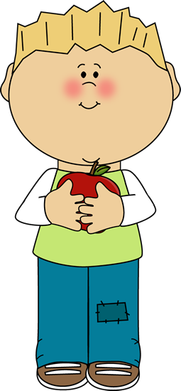

**A Peak at the Week** ; 

**Yummy! What is the delicious, crunchy fruit that we love to eat! It's a healthy treat! It's an apple! This week we learned all different fun facts about apples in honor of Johnny Appleseed’s Birthday on September 26th.We explored a variety of apple activities. We read the book Ten Apples Up on Top. We sang the song “Ten Little Apples.” Check out this online apple story “An Apple Grows”**

**We learned the poem: Five Red Apples**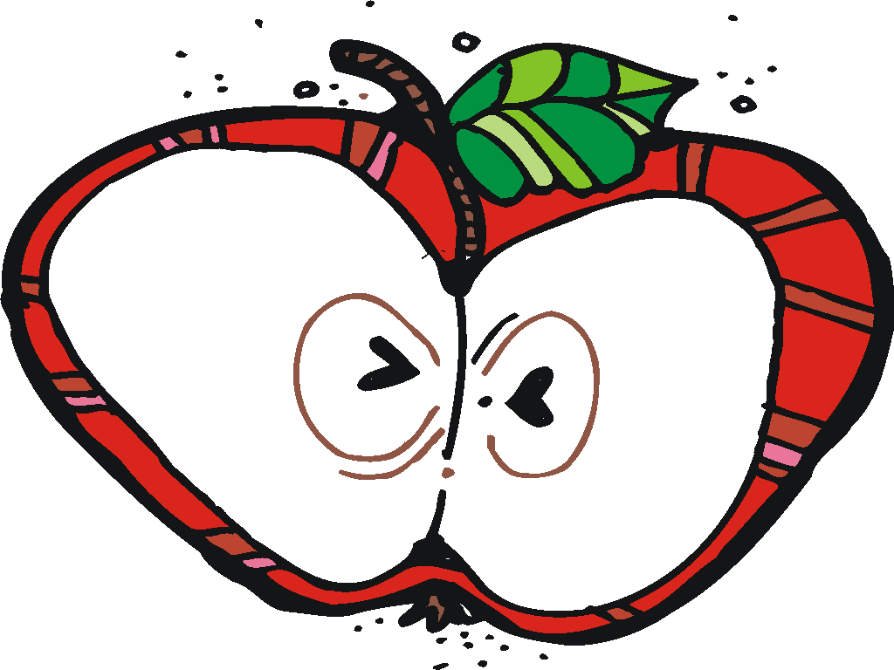

**Five red apples hanging in a tree, The juiciest apples you ever did see. The wind came by and gave an angry frown, And one little apple came tumbling down.  Four red apples…..etc.**

**We made apple prints and torn paper apples. We taste tested red, yellow and green apples. Then make a graph of the class favorite We started the Alphachant Book Letter “A”.We also started working in The Handwriting Without Tears Work books.**

     

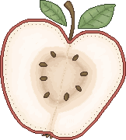 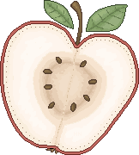 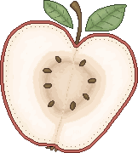                       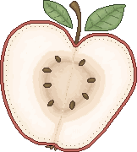  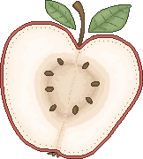                                                                                  

|  |  |  |
| --- | --- | --- |
|  |  |  |
|  | was the class favorite! |  |
|  |  |  |

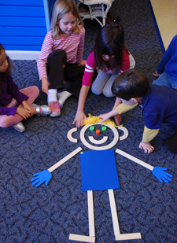

From classroom personality to storybook hero, Mat Man™ is a favorite among young children. Children first meet this charming character through the Handwriting Without Tears® Build Mat Man activity. Mat Man teaches important readiness skills:

* Body awareness
* Drawing & pre-writing
* Counting
* Building

Socializing & sharing

Math Mania

This week we worked on: Sorting and Counting orally from 0-10

Activities to do at home: Have your child sort, match and name coins at home. Count with your child often. Counting can be done almost anywhere. The car is a great place to count.

**School / Home Connection**



*FOLDERS*Every Friday, students will bring home their blue folders that may contain papers for parents and/or completed student work.  Please empty out the folders and have them keep their folders in their bags so that they can pack them up again the following week.   (If they keep forgetting, let me know and I'll ask them to check their bag!)

**Wednesday and Fridays are Gym days please were tennis shoes.**

If you call during the school day.I may not be able to call you back until my prep or after school. The best way to reach me during the school day is to email me at cathy.schell@fraserk12.org 

Please visit our classroom website at

http://dkdooleycenter.weebly.com

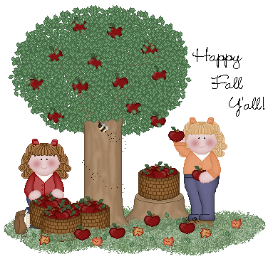

Rest time stuff goes home every Friday to be washed and returned on Monday

 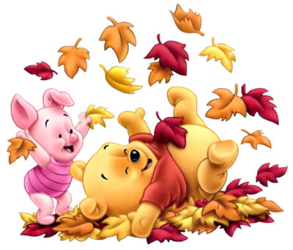

**Cold Weather**

* Please make sure your child is wearing warm enough clothing for playing outside. Some jackets are not thick/warm enough for cold weather. Also, make sure they are learning the skills of getting dressed by allowing them to put on their clothes all by themselves.

## Reporting your child’s absence:

## If your child is feeling sick or maybe your family is going out of town you need to report your child’s absence for any reason to the attendance line: 586.439.7690

Water Bottles

I am fine with having water bottles in the classroom. Please make sure the bottle is marked with your child’s name!

Next Week we will continued our Fall Unit and focus on “LEAVES”.



Smiles Mrs. Schell 