Mrs. Schell’s DK.

News October 11-15, 2021
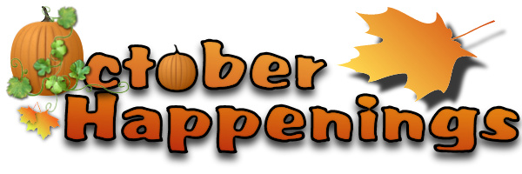
A Peak at the Week ; I can’t belive that we have been in school for 29 days ! Our classroom is beginning to look and feel alot like fall. :) The autumn colors can be seen in the falling leaves outside. We are enjoying the vibrant colors of the changing leaves, the harvest, and observe the seasonal changes in nature.We are singing “Grey Squirrel” and learning about squirrels and acorns. Alphachant letter “D” Story Champs 5 and 6In math we are practicing calendar and weather routines and learning more about patterns. We addressed the concepts of fire safety,. We also continue to develop our classroom and school week routines together.Take advantage of the nice fall weather and take a walk with your child to explore the season first-hand. Next week The Roseville Fire Department will visit Dooley

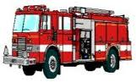

was the class favorite!

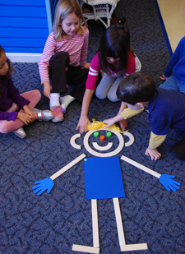
From classroom personality to storybook hero, Mat Man™ is a favorite among young children. Children first meet this charming character through the Handwriting Without Tears® Build Mat Man activity. Mat Man teaches important readiness skills:
- Body awareness
- Drawing & pre-writing
- Counting
- Building
Socializing & sharing
Math Mania
This week we worked on: Sorting and Counting orally from 0-10
Activities to do at home: Have your child sort, match and name coins at home. Count with your child often. Counting can be done almost anywhere. The car is a great place to count.

School / Home Connection

FOLDERS Every Friday, students will bring home their folders that may contain papers for parents and/or completed student work. Please empty out the folders and have them keep their folders in their bags so that they can pack them up again the following week. (If they keep forgetting, let me know and I'll ask them to check their bag!)

Wednesday and Fridaysare Gym days please were tennis shoes.

If you call during the school day.I may not be able to call you back until my prep or after school. The best way to reach me during the school day is to email me at cathy.schell@fraserk12.org

Reminder to send a Healthy snack for afternoon snack time

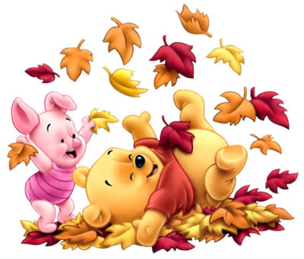We go outside every day, weather permitting. Please make sure your child wears clothing appropriate for cooler or wet days, so he/she will be comfortable, especially as the fall days grow chillier. Clothing labeled with your child’s name will help us to locate any lost items. Practice with snaps, buttons, zippers, and laces at home can help your child feel more confident dressing for outside when he/she is at school.

\
Reporting your child’s absence:

If your child is feeling sick or maybe your family is going out of town you need to report your child’s absence for any reason to the attendance line: 586.439.7690

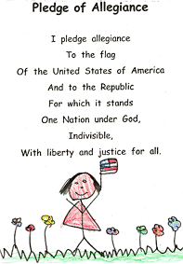 D.K students can recite the ‘Pledge of Allegiance.
Water Bottles
I am fine with having water bottles in the classroom. Please make sure the bottle is marked with your child’s name!Help us stay healthy
Please practice the following skills with your child
Blowing his or her own nose and disposing the tissue
Covering mouth by sneezing or coughing into the inside of the elbow

October Birthdays
KARTER

Next Week we will continued our Fall Unit and focus on “PUMPKINS” and BATS
Smiles Mrs. Schell
REMINDERS
EARLY RELEASE OCTOBER 29th Friday
We will have a very- key Halloween celebration details to follow
Children will be able to wear their costumes to school ( no Masks)

