Mrs. Schell’s D.K. Classroom News

November 29-December 3,2021

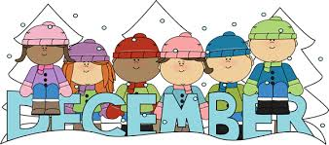

WOW!!! I cannot believe it is already December!
I want to welcome everyone back from the Thanksgiving holiday. As the holiday season approaches, we will be having fun sequencing, counting, sorting with a unit on Bears and hibernation We read the book Brown Bear, Brown Brear What Do You See and singing “Going on a Bear Hunt. Alpahchant letter”J” . We continue working in our Handwriting Without Tears books. Module #3 Eureka Math : Number 10 , Place Value ,Tallies and recognizing numbers . We also are working hard on Patterning

Language and Social Skills Focus
Believe it or not we are nearly half-way through the school year! Your children have grown in so many ways and have learned so much however, the second half of the year is more intense. We continue to raise our academic, language, social, and behavioral expectations for all of our students. We would like to see our students using the skills they have been taught on a more consistent basis and with less teacher intervention. Below you will find more specific language skills we have been targeting during December.
􏰁 Asking and answering yes/no questions accurately. 􏰁 Following all teacher directions in a timely manner. 􏰁 Using a friendly tone when responding to peers. 􏰁 Responding to greetings.
􏰁Addressing word order skills when making statements or asking questions
􏰁 Identifying “things” using specific vocabulary terms 􏰁 Providing praise and encouragement to one another 􏰁 Using please and thank-you! 􏰁 Dealing appropriately with change and feelings of
disappointment 􏰁 Coping skills when you are feeling anxious/afraid

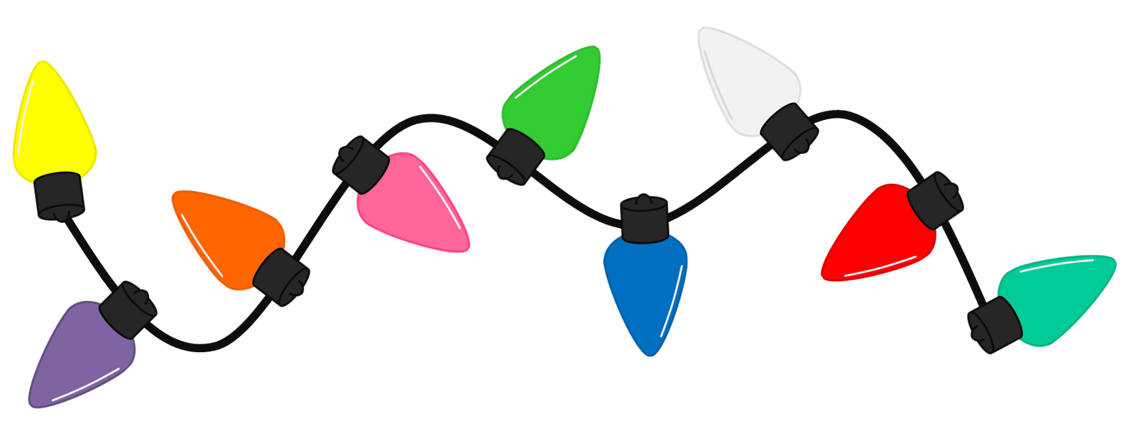

Language and Social Skills Focus
Believe it or not we are nearly half-way through the school year! Your children have grown in so many ways and have learned so much however, the second half of the year is more intense. I continue to raise our academic, language, social, and behavioral expectations for all of our students. I would like to see our students using the skills they have been taught on a more consistent basis and with less teacher intervention. Below you will find more specific language skills we have been targeting during December.
􏰁 Asking and answering yes/no questions accurately. 􏰁 Following all teacher directions in a timely manner. 􏰁 Using a friendly tone when responding to peers. 􏰁 Responding to greetings.
􏰁Addressing word order skills when making statements or asking questions
􏰁 Identifying “things” using specific vocabulary terms 􏰁 Providing praise and encouragement to one another 􏰁 Using please and thank-you! 􏰁 Dealing appropriately with change and feelings ofdisappointment 􏰁 Coping skills when you are feeling anxious/afraid

If you child is leaving school differently than usual, I will need a note in writing or a phone call about the change or dismissal plans

Winter Boots
When choosing boots for inevitable snow, please let your child put them on. If they cannot get the boots on or done up themselves maybe it would be wise to select another pair which your child would find less frustrating. Please also send shoes especially for gym days. Snowpants, It is important for your child to have snow pants so that their clothes are not wet when they come back into the classroom from recess Jackets and Zippers
Just a reminder that it would be extremely helpful if parents could help their child learn how to get their jackets on and off appropriately (without the sleeves turned inside out), and to do up their zipper independently. It would make a big difference at recess and home time for us.
Wednesday and Friday are Gym days please send tennis shoes.

If you call during the school day.I may not be able to call you back until my prep or after school. The best way to reach me during the school day is to email me at cathy.schell@fraserk12.org

As a parent you are your . . .
Child’s 1st Teacher
F ind ways to make learning fun every day in
every way.
I nspire your child to always do his or her best.
R ead together often, even after your child can read alone.
S how sensitivity to your child’s feelings and uniqueness.
T each your child to treat others the way he or she wants to be treated.
T ake time to talk to your child and make it a point to listen attentively.
E njoy quality time together to build bonds that will last forever.
A cknowledge your child’s efforts as well as achievements.
C orrect inappropriate behavior with disci- pline that’s firm, but fair and loving.
H elp your child develop a positive attitude and appreciate the joys of life.
E ncourage your child to think choices through in order to make wise decisions.
R einforce your child’s self-esteem with lots of hugs, kisses, smiles, and praise.
Remember— You teach by example . . . So always be a great role model

If your child is feeling sick or maybe your family is going out of town you need to report your child’s absence for any reason to the attendance line: 586.439.7690

REMINDERS : December 8 and 9 are conferences
December 9th is 11;45 Dismissal
Questions or Concerns
Please make sure that if there are any questions or concerns that you get in touch with me right away. I will do all that I can to help you out! ☺
Smiles Mrs. Schell and Ms. Darlene

