Mrs. Schell’s D.K. Classroom News

November 15-19 , 2021
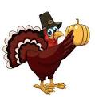

A Peak at the Week: Many activities are taking place and I hope your child has been sharing these with you! We are writing letters in shaving cream , matching upper and lower case letters, making letters out of play-doh . Letter Play provides fun with multisensory play with the bonus of enabling children to learn correct writing habits from the start. Children learn in Handwriting Without Tears that all letter are formed using Big Lines ,Little Lines ,Big Curves and Little Curves

Conferences are on

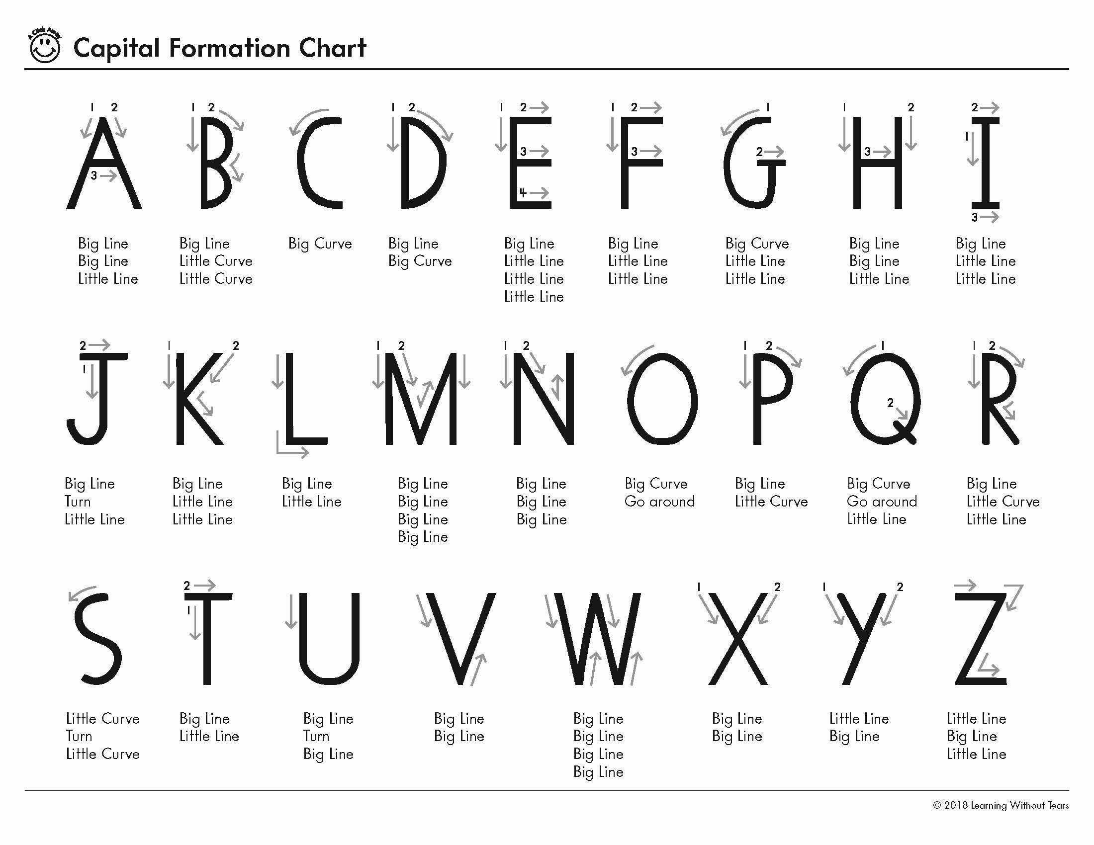
This semester our Science unit is Transportation Land ,Air and Sea.
Winter Boots
When choosing boots for inevitable snow, please let your child put them on. If they cannot get the boots on or done up themselves maybe it would be wise to select another pair which your child would find less frustrating. Please also send shoes especially for gym days. Snowpants, It is important for your child to have snow pants so that their clothes are not wet when they come back into the classroom from recess Jackets and Zippers
Just a reminder that it would be extremely helpful if parents could help their child learn how to get their jackets on and off appropriately (without the sleeves turned inside out), and to do up their zipper independently. It would make a big difference at recess and home time for us.
Wednesday and Friday are Gym days please were tennis shoes.

If you call during the school day.I may not be able to call you back until my prep or after school. The best way to reach me during the school day is to email me at cathy.schell@fraserk12.org

If your child is feeling sick or maybe your family is going out of town you need to report your child’s absence for any reason to the attendance line: 586.439.7690
Some tips for asking about their day may include some specific questions such as: What did you talk about in group time? What center did you choose to play at? What craft did you make? Who did you sit beside today? Sometimes children will suddenly remember something about the day when you ask more specific questions that remind them of something special that happened!

Smiles Mrs. Schell
Questions or Concerns
Please make sure that if there are any questions or concerns that you get in touch with me right away. I will do all that I can to help you out! ☺
Please note that there will be NO newsletter until the first week of December
Happy Thanksgiving to You and Yours
Smiles Mrs. Schell and Ms. Darlene

