Mrs. Schell’s D.K. Classroom News

December 13-17,2021
I was so nice to talk to all the parents at conferences. I certainly have an awesome group of students! What an amazing D.K community we have! Thank you, also, so much for your ongoing support . The children have come along really well in their learning. This week and next week are theme is Christmas: reindeer,elves,Santa etc. Alphachant is the letter “L” We continue practicing our cutting skills .patterning and working in our Handwriting Without Tears books
This will be the last newsletter until January
Ms Darlene and I wish all the children and their families as wonderful Christmas !

Language and Social Skills Focus
Believe it or not we are nearly half-way through the school year! Your children have grown in so many ways and have learned so much however, the second half of the year is more intense. We continue to raise our academic, language, social, and behavioral expectations for all of our students. We would like to see our students using the skills they have been taught on a more consistent basis and with less teacher intervention. Below you will find more specific language skills we have been targeting during December.
􏰁 Asking and answering yes/no questions accurately. 􏰁 Following all teacher directions in a timely manner. 􏰁 Using a friendly tone when responding to peers. 􏰁 Responding to greetings.
􏰁Addressing word order skills when making statements or asking questions
􏰁 Identifying “things” using specific vocabulary terms 􏰁 Providing praise and encouragement to one another 􏰁 Using please and thank-you! 􏰁 Dealing appropriately with change and feelings of
disappointment 􏰁 Coping skills when you are feeling anxious/afraid

Monday and Wednesday are Gym days please were tennis shoes.

If you call during the school day.I may not be able to call you back until my prep or after school. The best way to reach me during the school day is to email me at cathy.schell@fraserk12.org
If your child is going to be absent and rides the bus, please do not call Dooley to call the bus garage. You can call directly transportation at 585 4397100
Just a reminder to please send in labeled snowpants that can stay in school We go outside in the snow .
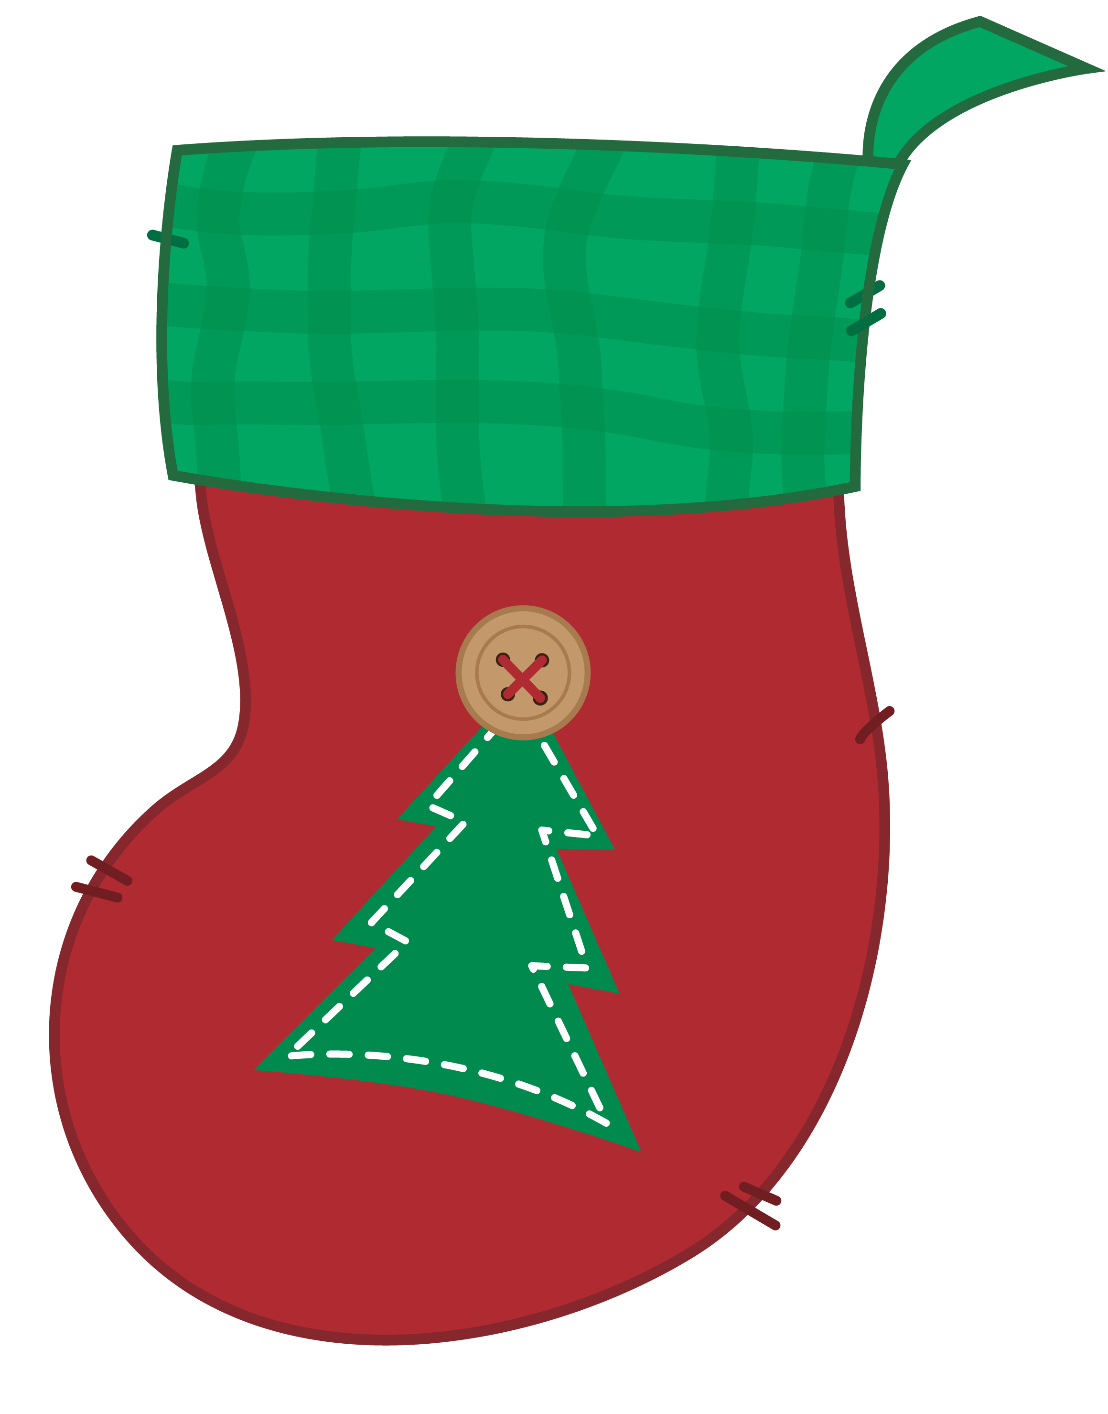
DECEMBER 22 Last Day of School “Holiday Celebration School resumes January 4th
Smiles Mrs. Schell and Ms. Darlene
Our Holiday Celebration December 22nd
We will have Holidays centers and games and watch a movie
If you would like to send in a treat for the class there are 12 students
Cliparts Zone

PRINT
DOWNLOAD
Facebook
Twitter
Tumblr
E-Mail
Pinterest
WhatsApp

